**GMIEC user manual**

**v0.01**

Table of Contents

List of figures 3

How to install GMIEC 4

How to run GMIEC 4

GMIEC graphic interface 5

GMIEC-AN: type of analysis 5

GMIEC-AN: Input data 6

GMIEC-AN: Upload of the data 7

Upload file with the association between genes and drugs 8

Upload of annotation file and bed file 8

GMIEC-AN: parameters for the analysis 9

How to run GMIEC-AN 9

Analysis with a gene-list 9

Analysis with a bed file 10

Analysis with all genes 10

Analysis with few omics datasets 11

How to run GMIEC-VIS 12

How to run GMIEC-res 12

Parsing output GMIEC-AN 12

Visualization of the modules 13

# **List of figures**

Figure 1. GMIEC interface. 5

Figure 2. Options to run GMIEC-AN 5

Figure 3. Window that shows how to upload the omics data (gene-expression, copy-number, methylation, mutation, clinical) 7

Figure 4. This window shows the options to check in order to run GMIEC-AN 8

Figure *5*. A file and a list of genes can be uploaded through the “Type of Analysis” window. 8

Figure 6. The users can upload the annotation files through the annotation window. 9

Figure 7. Steps of the analysis if a custom genes list is provided. 9

Figure 8. Steps of the analysis if a bed file is provided. 10

Figure 9. Steps of analysis considering all genes in the datasets. 11

Figure 10. Procedure to run GMIEC with few data-sets. 11

Figure 11. Interface of GMIEC-VIS 12

Figure 12 Window to parse the GMIEC-AN output 13

Figure 13. Procedure to run GMIEC-res and visualize the modules. 14

# **How to install GMIEC**

From the *INSTALL.R* file, which is located in the official GMIEC git-hub repository (https://github.com/guidmt/GMIEC-shiny), copy and paste the R code in the R-shell.

install.packages(c("shiny",

"shinydashboard",

"klaR",

"formattable",

"bcp",

"plyr",

"kableExtra",

"randomForest",

"heatmaply"),depencies=T)

if (!requireNamespace("BiocManager", quietly = TRUE))

install.packages("BiocManager")

BiocManager::install("ChIPpeakAnno")

BiocManager::install("ComplexHeatmap")

Alternatively, advanced users can easily run the script as follows:

source(‘INSTALL.R’)

# **How to run GMIEC**

Copy-paste the following R-code in the R-shell:

library(shiny)

library(ComplexHeatmap)

setwd("/directory/GMIEC_shiny2-master")

options(shiny.fullstacktrace=TRUE)

shinyAppDir(appDir="/directory/GMIEC_shiny2-master")

# **GMIEC graphic interface**

After these two preliminary steps (How to install and How to run GMIEC, pag.4), GMIEC will be opened as graphical interface in a new separate window (Figure 1.).

The homepage pops-up, showing a brief description of the tool functionalities. Through the left menu, the user can explore the applications of GMIEC: run the analysis (“GMIEC-AN”), view the results summary (GMIEC-results) and visualize the resulting data via plots (“GMIEC-VIS”).

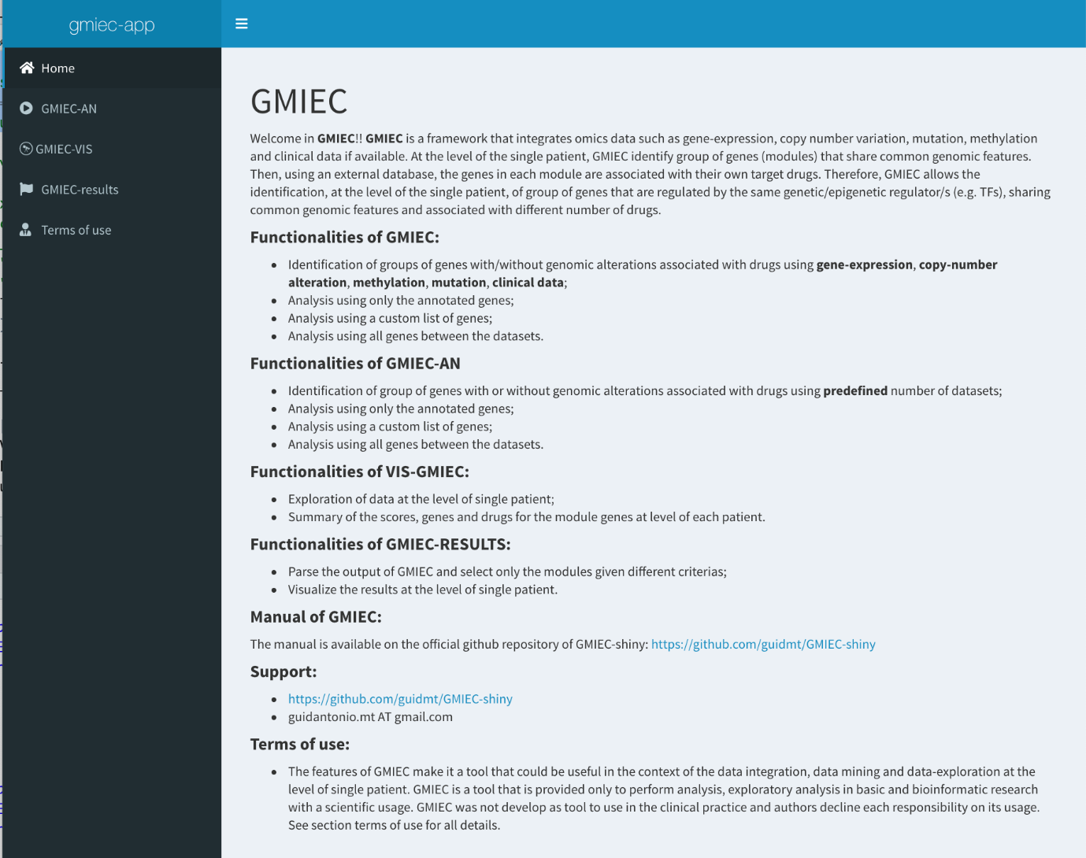

Figure 1. GMIEC interface.

# **GMIEC-AN: type of analysis**

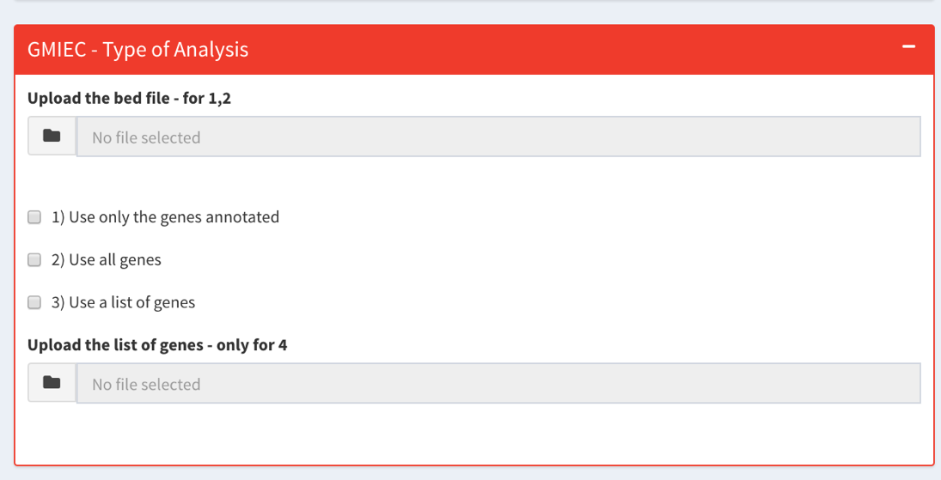GMIEC-AN is the core function of GMIEC. Omics analyses can be performed starting from different types of data (copy number, gene-expression, mutations, methylation, etc.). The user can choose between “Use only the annotated genes”, if the uploaded file is a bed file, or “Use a list of genes”, if the analysis has to be done just for a restricted cluster of genes of interest.

Figure 2. Options to run GMIEC-AN

# **GMIEC-AN: Input data**

The input files required for GMIEC usage are:

1. omics data: gene-expression, copy-number, epigenetics and mutations data, given in tab-delimited format. In case of genetic variants data, the user has to create a new file reporting only the mutations of interest (e.g. deleterious variants).
2. drugs-genes table: tab-delimited file describing the association between genes and drugs. The user can compile it writing the most important drugs and genes associated to a particular disease, or downloading these informations from a public repository.
3. clinical data: tab-delimited file, explaining some clinical variables that have to be included in the analysis.
4. list of genes: list of genes of particular interest (e.g. genes of a pathway), that can be directly uploaded by the user, or that can be obtained through an annotation step from given genomic coordinates.

GMIEC principal outputs are shown as tab-delimited files, reporting genes and drugs modules (GMs or DMs), that can be easily open with Microsoft Excel or Libre/Open Office. The reported scores in GMs represent the quantification of the genomic levels of genes alterations, while DMs specify the drugs fraction related to a specific GM. GMIEC also allows the generation of GMIEC-VIS, a dynamic report (see Figure S1), that can be directly interrogated through a GUI interface. Finally, GMIEC-results represents another GMIEC sub-application that parses the output, automatically selects a module for each patient, and can be used to visualize differences in the levels of omics data for each gene. In order to use GMIEC-VIS and GMIEC-results the user has to upload the GMIEC-AN resulting output before.

# **GMIEC-AN: Upload of the data**

A mandatory condition to run GMIEC-AN analysis is the uploading of a minimum of two omics datasets: the clinical table and the gene-drugs association file. These file can be downloaded from public databases such as DGIdb, which is useful for cancer drugs/genes associations (Figure 3). Some pre-written datasets are included in the “datasets” folder, to be used by the users to become familiar with GMIEC.

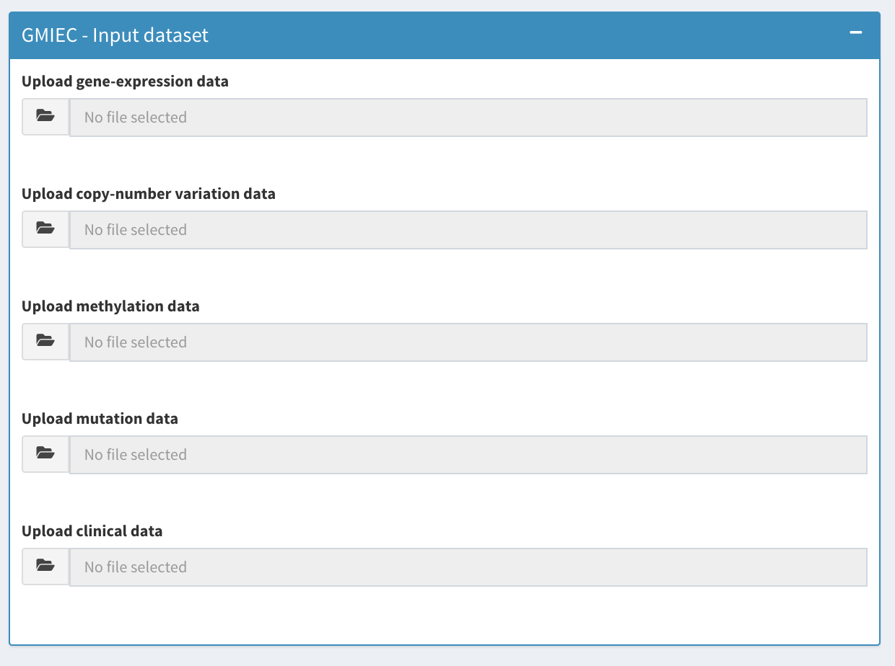

Figure 3. Window that shows how to upload the omics data (gene-expression, copy-number, methylation, mutation, clinical)

Using two datasets (e.g. gene-expression or copy number data) the user should check the “Analysis only two datasets” option (Figure 4), and confirm which are the data that have just been uploaded (e.g. gene-expression, methylation, etc).

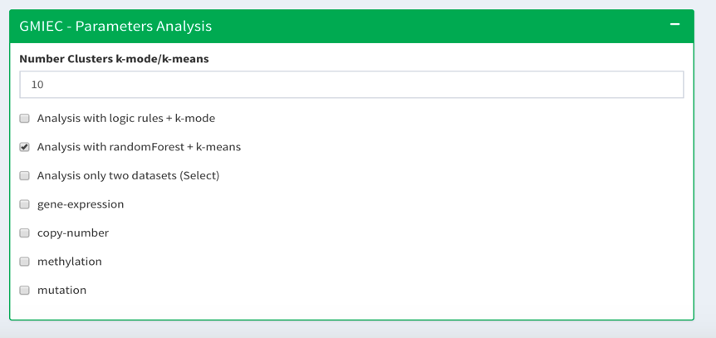Figure 4. This window shows the options to check in order to run GMIEC-AN

## Upload file with the association between genes and drugs

The uploading of the genes/drugs association file is mandatory. To do that, the user should use the specific panel named “GMIEC-input drugs”.

## Upload of annotation file and bed file

The user can upload a bed file that will be annotated by GMIEC-AN in order to get the gene-set for the analysis. The user has to fill the “GMIEC – Type of Analysis” window, uploading the corresponding annotation file (e.g. from RefSeq) and specifying which are the correct annotation parameters (“GMIEC – Input annotation”).

****Figure *5*. A file and a list of genes can be uploaded through the “Type of Analysis” window.

Figure 6. The users can upload the annotation files through the annotation window.

# **GMIEC-AN: parameters for the analysis**

Figure 4 shows two different methods that can be selected to analyse the data: “Analysis with logic rules + kmeans” or “analysis with randomForest + k-means”

# **How to run GMIEC-AN**

## Analysis with a gene-list

1. Upload the omics data (e.g. gene-expression, copy-number, methylation, mutation, clinical). The file with the clinical information is mandatory.
2. Upload a table delimited file with the association between the genes and the drugs. This file is mandatory.
3. Click on “Use a list of genes”, and upload the list of genes.
4. Change the analysis parameters.
5. Click on “Run analysis” and wait for its end.
6. Click on “Download”.



Figure 7. Steps of the analysis if a custom genes list is provided.

## Analysis with a bed file

1. Upload the omics data (e.g. gene-expression, copy-number, methylation, mutation, clinical). The file with the clinical information is mandatory.
2. Upload a table delimited file with the association between the genes and the drugs. This file is mandatory.
3. Upload an annotation file using the window “GMIEC – Input annotation”, and specify the distance of annotation.
4. Use the “Type of analysis” interface to upload the bed file. Specify “Use only the genes annotated”.
5. Click on “Run analysis”, and wait for its end.
6. Click on “Download”.



Figure 8. Steps of the analysis if a bed file is provided.

## Analysis with all genes

1. Upload the omics data (e.g. gene-expression, copy-number, methylation, mutation, clinical). The file with the clinical information is mandatory.
2. Upload a table delimited file with the association between the genes and the drugs. This file is mandatory.
3. Click on “Use all genes”.
4. Change the analysis parameters.
5. Click on “Run analysis”, and wait for its end.
6. Click on “Download”.



Figure 9. Steps of analysis considering all genes in the datasets.

## Analysis with few omics datasets

The user should upload a minimum of two omics data-sets (e.g. gene-expression, copy-number). Indipendently on the analysis type (use a list of genes, use only the annotated genes, all genes), the user can run GMIEC-AN as follows:

1. Upload the gene-expression, copy-number and clinical data.
2. Click on “Analysis only two datasets”.
3. Specify the type of the uploaded data-sets (e.g. gene-expression, copy-number).
4. Use the procedures described above to start the analysis.



Figure 10. Procedure to run GMIEC with few data-sets.

# How to run GMIEC-VIS

GMIEC-Visualization (GMIEC-VIS) is an interface that allows the exploration of GMIEC-AN results. This application consists of two sub-sections. “*Summary Heatmaps GMIEC’*”, brings to the visualization of some interactive heatmaps that show the values of drugs, genes, sad or *S-score* values computed by GMIEC-AN (Supplementary Figure 4). The second section is used to inspect the results at single patient level, giving a table in which several statistics for each module are reported (e.g. number of genes, number of drugs, scores drugs, scores genes, sad or *S-score*). GMIEC-VIS generates also other tables of drugs and genes associations, including a module with external links to NCBI and DGIdb.

Procedure to run GMIEC-VIS:

1. Upload the output of GMIEC-AN using the window “Upload results GMIEC”.
2. Click on ‘Create report!’, and wait for the results.

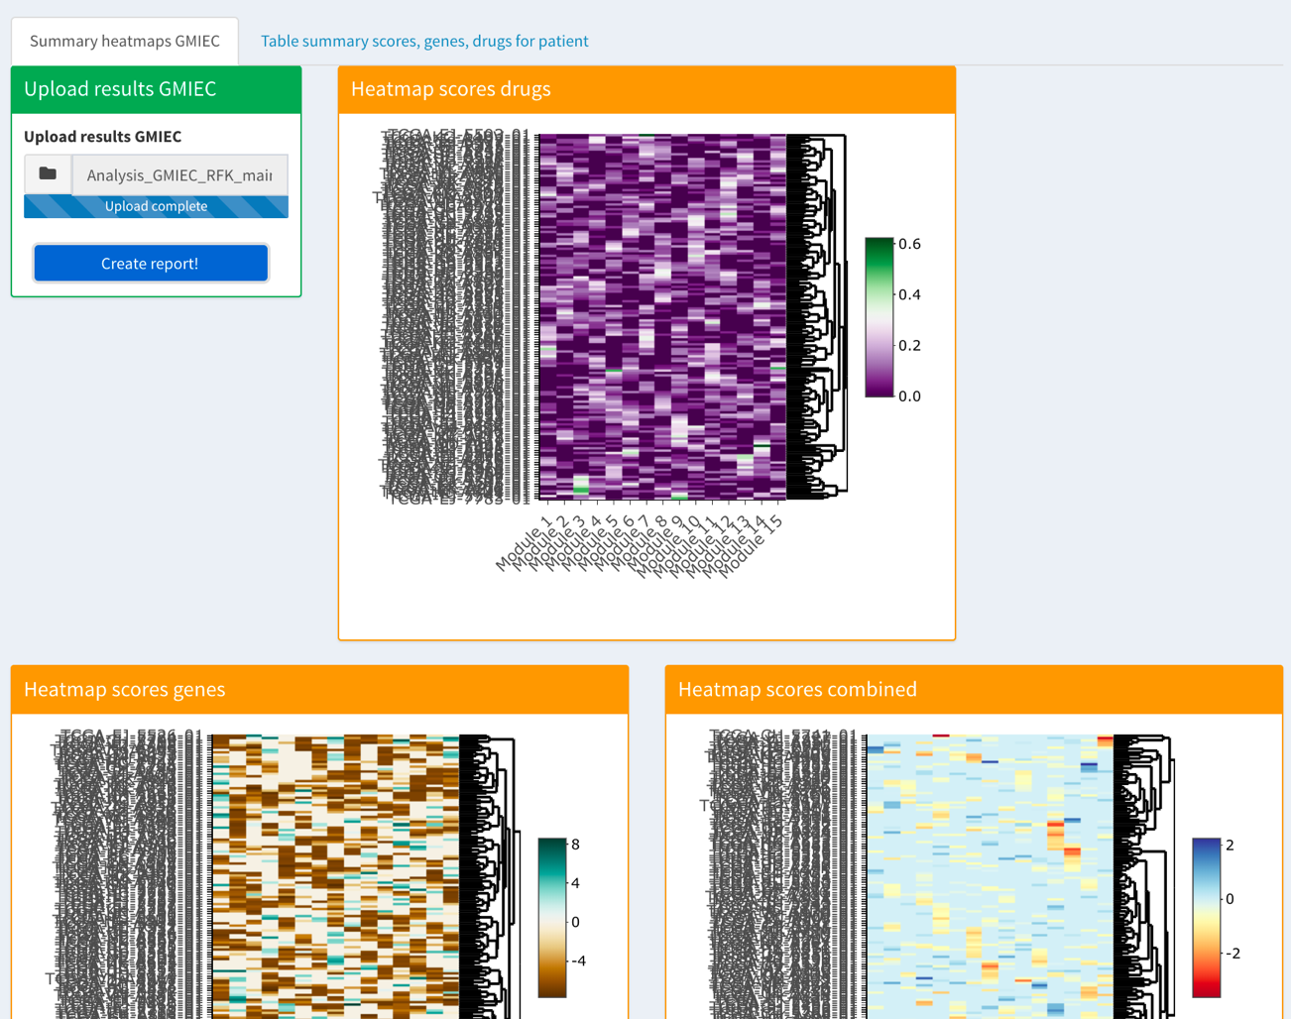

Figure 11. Interface of GMIEC-VIS

# How to run GMIEC-res

## Parsing output GMIEC-AN

The GMIEC-AN output can be uploaded on GMIEC-results. This application allows i) automatic selection of the modules from each patient ii) parsing of GMIEC-AN output in a simpler form iii) visualization of GMIEC-AN results.

GMIEC-results can select groups of genes referred to a single patient that are over-activated (e.g. genes with high copy-number) or over-suppressed (e.g. genes hypermethylated), and hence, genes that are targets of drugs (See Supplementary Material and Methods for details). Although this method is a simplification, GMIEC-results should represent a straightforward approach to support the users with few computational skills in parsing the output of GMIEC-AN and identifying which are the most relevant biological modules. Advanced users can work directly on the original GMIEC-AN outputs and apply custom approaches. GMIEC-results is built as a table, in which each row corresponds to a single patient, while each column represents the patient id, the module score, the genes and the drugs.

GMIEC-results implements four strategy that prioritizes the modules of each patient, based on the maximum or the minimum values of *S-score* and SAD score:

* Module active: GMIEC-results selects from each patient only the module with the highest score *S-score.*  This method can be useful to detect the most active groups of genes in one patient.
* Module inactive: GMIEC-results identifies, for each, only the module with the lowest *S-score*. This approach can be useful to detect the most inactive groups of genes in one patient.
* Module active with drugs: GMIEC-results identifies, for each patient, only the module with the maximum SAD score. This method can be useful to detect the most inactive groups of genes in one patient.
* Module inactive with drugs: GMIEC-results identifies, for each patient, only the module with the lowest SAD score. This method can be useful to detect the groups of inactive genes associated with drugs.

Procedure to run GMIEC-res and parse the output of GMIEC-AN:

1. Upload the output of GMIEC-AN.
2. Select the methods for the analysis.
3. Choose the output type.
4. Click on “Create Report” and wait for the end of the analysis. Then, click on “Download”

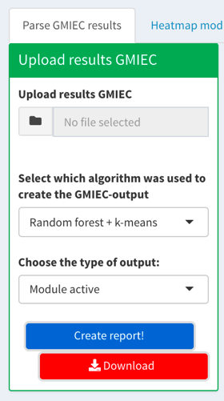

Figure 12 Window to parse the GMIEC-AN output

## Visualization of the modules

1. Click on the tab “Heatmap module patient”
2. Upload the results of “Parse GMIEC results” in the field “Upload results GMIEC”
3. Upload the gene-expression copy-number, methylation, mutation, and genes-drugs files.
4. Click on “Create report” and wait for the end of the analysis.
5. Select the ID of the patient to visualize the module of selected patient.



Figure 13. Procedure to run GMIEC-res and visualize the modules.